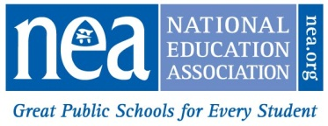
NATIONAL EDUCATION ASSOCIATION
2023-24 Aspiring Educator Rebate Application

Complete form and mail or email on or before June 1, 2024 to:
Mail: Or Email:
NEA Business & Financial Services Attn: Student Rebate
1201 16th Street, NW, Ste. 410 studentrebate@nea.org
Washington, DC 20036-3290

PLEASE CLEARLY PRINT or TYPE
NEA INDIVIDUAL ID
Or SSN 4
First NAME: |  | last name:
former last name if needed to verify mbshp
Address:
CITY: |  |  | STATE: |  |  | ZIP:
PERSONAL EMAIL ADDRESS:

Rebate of $20 for each year you held a Student membership up to four years will be issued provided the following requirements are met:

- 2023-24 must be your first year of educational employment and you must currently hold NEA Active membership. Substitute members are not eligible for the rebate.
- Previously you were an NEA Aspiring Ed member. Please do not submit an application if you have never held an NEA Aspiring Ed membership.
- NEA will verify your membership and eligibility and mail a rebate check to the address on the application in August 2024. If your address changes before August 2024 please send the updated address to studentrebate@nea.org
- NEA will not contact you prior to mailing your rebate check unless additional information is required. DO NOT SUBMIT MULTIPLE APPLICATIONS. This could delay processing!
Below is a record of my college or NEA chapter/state affiliate while I was an NEA Aspiring Educator member:
Year(s) NEA STUDENT MEMBERSHIP Was Held, e.g., 2022-2023 | NEA CHAPTER & STATE or COLLEGE WHEN  STUDENT MEMBERSHIP WAS HELD

SIGNATURE: DATE:

For NEA Use Only

